Name: Pavan Bhapkar

PRN: 24070126137

Batch: AIML 24-28 B3

Experiment 1

Book Inventory system with exception handling
- Create a Book class with appropriate constructors.
- Create a User defined exception class called InvalidPriceException.
- One of the constructors of Book should throw InvalidPriceException if the price < 0.
- Create another class called ArrayListOfBooks with main method.
- Create multiple Book objects and add them to an ArrayList of Books.
- Use the constructor that throws InvalidPriceException inside a try-catch block and try to create a Book object with negative price value.
- The output should display the attribute values of all objects from the ArrayList. Also, calculate the average price of books and print it.
- Also, print books of a particular genre such as "Fiction" using forEach() method of ArrayList.

#book.java
public class book { public String title; public double price; public String ISBN; public String genre; public String author; public book(){
title = "Ready Player One"; price = 458;
ISBN = "ABR4212";
genre = "Fiction"; author = "Ernest Cline";
}

public book(String title, double price, String genre ) throws InvalidPriceException, InvalidBookGenreException
{
this.title = title; if (price<0)
throw new InvalidPriceException("Price cannot be negative"); this.price = price;
if (!genre.equals("Fiction") && !genre.equals("Non-fiction") && !genre.equals("Auto-biography"))
throw new InvalidBookGenreException("Invalid genre"); this.genre = genre;
}

public book(String title, double price, String ISBN, String genre, String author) throws InvalidPriceException, InvalidBookGenreException
{
this.title = title; if (price<0)
throw new InvalidPriceException("Price cannot be negative"); this.price = price;
this.ISBN = ISBN;
if (!genre.equals("Fiction") && !genre.equals("Non-fiction") && !genre.equals("Auto-biography"))
throw new InvalidBookGenreException("Invalid genre"); this.genre = genre;
this.author = author;
}

public book(book b){ this.title = b.title; this.price = b.price; this.ISBN = b.ISBN;
this.genre = b.genre; this.author = b.author;
}
}

#mainbook.java
import java.util.ArrayList; public class mainbook {
public static void main(String[] args) { ArrayList<book> alb = new ArrayList<book>(); try{
book b1 = new book("Icon", 499, "Fiction"); alb.add(b1);

book b2 = new book(); alb.add(b2);

book b3 = new book(b2); b3.title = "Harry Potter"; b3.author="JK Rowling"; alb.add(b3);

book b4 = new book("Outlive", 370, "ABDK223", "Nonfiction", "Peter Attia"); alb.add(b4);
book b5 = new book("My experients with truth", 549, "ABCD3101", "Fiction", "Mahatama Gandhi");
alb.add(b5);
book b6 = new book("Mein Kampf", 999, "NA67ZI", "Auto-biography", "Adolf Hitler"); alb.add(b6);
}
catch(InvalidPriceException ip){ System.out.println(ip.getMessage());
}
catch(InvalidBookGenreException ibg){ System.out.println(ibg.getMessage());
}

int temp = 0; int[] len = {0};
alb.forEach(b -> { if(b.genre.equals("Fiction")){
System.out.println(" ");
System.out.println(b.title); System.out.println(b.price); System.out.println(b.author); System.out.println(b.ISBN); System.out.println(b.genre);

}
});
System.out.println(" ");
len[0] += 1;

System.out.println("Fiction books: " + len[0]); len[0] = 0;
for(book b : alb){ len[0] += 1; temp += b.price;
}
System.out.println("Average price: " + (temp / len[0]));

}
}

#InvalidPriceException
public class InvalidPriceException extends Exception{ public InvalidPriceException(String m){
super(m);
}
}

#InvalidBookGenreException
public class InvalidBookGenreException extends Exception{ public InvalidBookGenreException(String msg){
super(msg);
}
}

#OUTPUTS

Printing fiction books and its count, and then calculating overall average price.

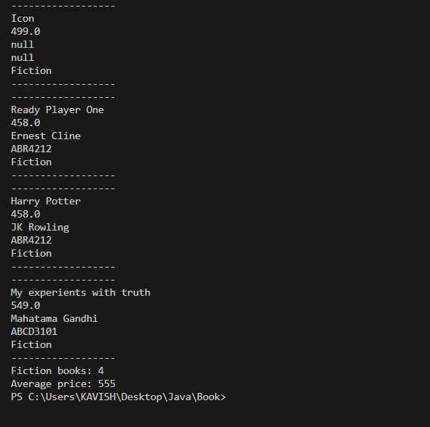

#Exception Cases

One of the prices has been set to negative.

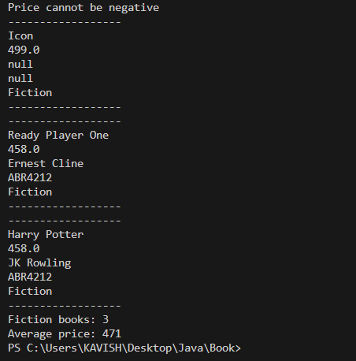

- One of the genres is entered/spelled wrongly.

